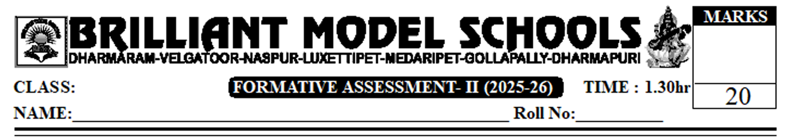

X Social

I. Answer the following questions. 2x2=4
1. How does deforestation affect global warming?
2. Which Qualities do you like in Subhash Chandra Bose? Why?
II. Answer any two of the following questions. 2x3=6
3. A) Explain Himalayan River system (or)
B) Describe the Monsoon Mechanism in India.
4. A) How did Partition effect the lives of ordinary people? What was the political response to
mass migration following partition? (or)
B) Integration of various princely states into the new Indian nation was a challenging task. Explain.
III. Answer any one of the following question. 1x4=4
5. Read the following paragraph and write your opinion on it
What is required are laws and rules to recognize that water is a common flowing resource. Drinking water is the first priority as well as a human right and that Panchayat Raj institutions must have control over the use of ground water.
Or
Make a list of various reasons for the partition of the country.
IV. Locate the following places in India Map. 4x1/2=2
- River Narmda b) Tungabhadra c) Penna d) Cauveri
Or
Locate the following places in World Map.
- London b) Japan c) Nigeria d) Pakistan

PART - B.
V. Choose the correct answer. 8x1/2 = 4
- The largest Peninsular river is? ( )
A) kaveri B) Tungabhadra C) Godavari D) Krishna
- This is not a tributary of river Ganga. ( )
A) Sutlej B) Son C) Yamuna D) Gandak
- Example of a Peninsular river... ( )
A) Ganga river B) Indus river C) Brahmaputra river D) Godavari
- Aquifers get recharged during.... ( )
A) winter B) Spring C) Summer D) Monsoon Months
- .... was given charge of integration of states in 1947. ( )
A) Jawaharlal Nehru B) Sardar Patel C) M. Gandhi D) B.R. Ambedkar.
- Muslim League was formed in ... ( )
A) 1916 B) 1909 C) 1906 D) 1905
- In Feb, 1947 Wavell was replaced as viceroy by ... ( )
A) Cripps B) Curzon C) Mount batten D) Minto
- The Govt of India abolished privy purses in ... ( )
A) 1949 B) 1970 C) 1971 D) 1961

